REMEDIAL REPORT
Report on How the Institution Assesses Learning Levels of Students And Organises Special Programs for Advanced Learners And Slow Learners

The institution focuses on assessing learning levels of students and thereby, identify those that are advanced learners and those that are slow learners. Following this, special programs are organised for advanced learners and slow learners to help utilise their potential.

It has been a practice of the department to train students in the areas of communication skills, personality development, time management and organise motivational sessions every year. Furthermore, to motivate both the advanced and slow learners, workshops are organised aiming to enhance the students’ skills. Moreover, guest lectures are arranged for the students to help them gain industrial and practical knowledge from experts.

The assessment of learning levels is primarily based on students’ performance in internal assessment exams, university examinations and classroom involvement and interaction. Based on this assessment, the institution takes steps to organise special programs for advanced learners and slow learners. This is further elaborated below.

Slow Learners:
For slow learners, remedial coaching is given to slow learners personal mentoring. Remedial teaching involves re-teaching concepts to students using techniques and methods that would facilitate understanding. The students are also motivated with extra care and special initiatives. Further, the students’ performance is monitored and is communicated to parents along with their attendance. They are also given personal attention from faculty to help them overcome any difficulty they might be facing academically. Further, the students are also provided with course notes to students, especially for those who are slow learners and those at the verge of dropping out due to arrear subjects. The faculty also provide them with a university question bank and discuss with them the ways in which they can present answers in the examination to help the students score better.

Among slow learners, students who belong to a rural background and have had Telugu as the medium of instruction so far, are made to sit closer to the front and special attention is given to them. They are also given assignments on different topics and asked to refer books and finally submit a written report on the topics. Moreover, faculty members ensure revision of topics of difficulty as per students’ requisition. Additionally, extra classes are conducted to clarify students’ doubts and critical topics are re-explained to facilitate understanding. Besides, appropriate counselling with additional teaching is undertaken which eventually results in students’ regular attendance of classes. In addition, mutual helpfulness among students is encouraged so that they can help each other learn.

Advanced Learners:

When students are identified as being advanced learners, they are encouraged to take part in workshops, seminars, group discussions and quizzes to help them develop their analytical and problem solving abilities. Advanced learners are also encouraged to participate in other institutions in all academic competitions like quizzes, case study analysis, preparation of business models etc. In addition, students also actively participate in various clubs such as innovation and incubation clubs. Furthermore students also present papers and write articles for department journals. Also, the students are provided with opportunities to develop their creativity through organising and participating in intercollegiate seminars and conferences. Advanced learners are also encouraged to take up NPTEL courses to gain additional knowledge.

In advanced learners, students who are interested in pursuing higher education approach respective subject lecturers to get guidance on preparing for entrance exams for higher educational institutions. In addition, students are guided to attend various seminars and workshops and motivated to present papers and posters at various events. Advanced learners are also encouraged to take competitive exams and are helped to prepare for the same.

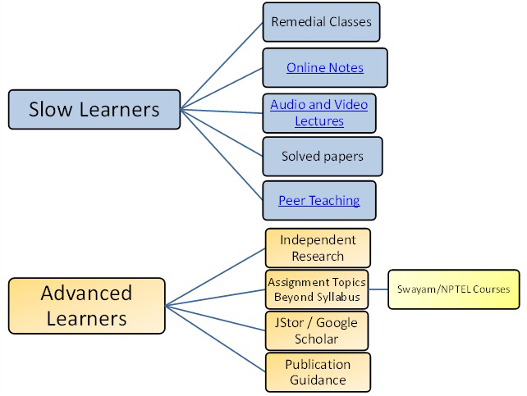

The following is an account of certain departments pertaining to assessment of learning levels and organising programs for advanced learners and slow learners:

Department of B.Com - International Accounting and Finance (IAF):

The department of B.Com International Accounting and Finance conducts an orientation program regarding the ACCA course and its framework by ISDc Hyderabad for the first year students.

Advanced Learners:
Advanced learners are encouraged to take the ACCA online exam and clear the F-level papers. In order to help them prepare for the same, the department conducts 60 hour tutorial classes where ACCA professionals teach and guide the students. Additionally, several mock tests are conducted in the college campus itself to facilitate preparation for those appearing for the ACCA online exam. In addition to the above, the students are also encouraged to take competitive exams like GATE, GRE, TOEFL, IELTS, CAT, PGCET etc. Additionally, students who are interested in pursuing higher education approach respective subject lecturers to get guidance on preparing for entrance exams for higher educational institutions, especially for coaching for ICAR (Indian Council of Agricultural Research) M.Sc. entrance exams.

Slow Learners:
The faculty of the department tries to build confidence in students who are slow learners to take the ACCA online exam. Such students are given regular class tests to help improve their performance in the university exam. They are also given assignments on different topics and asked to refer books and finally submit a written report on the topics. These topics are also discussed in practical classes to facilitate better understanding. Moreover, regular slip tests are conducted to assess the students’ performance. Additionally, following the declaration of the results of the Semester-end examination, those that failed in various subjects were provided remedial coaching during the sixth hour. Besides, in order to help prepare students to answer a variety of questions, they are provided with previous years question papers and made to practice answers to the questions. Furthermore, parents are also notified regarding students’ performance and asked to take special care wherever needed.

This dept applied an individual and peer teaching methods to give the basics to students to clear their subjects in semester subjects.

Department of B.Sc - Computer Science and Engineering:

Computer Science and Engineering (CSE) is a field of study that combines principles and practices of both computer science and engineering to develop innovative solutions for a wide range of technological problems. The field is concerned with the design, development, and implementation of software and hardware systems that enable the efficient and effective processing of information.
This dept applied an individual and Skill based teaching methods to give the basics to students to clear their subjects in semester subjects.

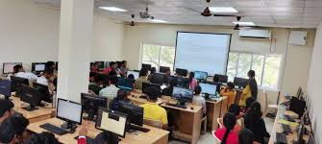

Slow Learners:
The department assists slow learners by re-explaining important topics from the syllabus in an easier manner. Remedial teaching is the use of activities, techniques and practices to help students overcome any sort of difficulty they might be facing that could be prohibiting their academic progress and giving them personal attention for better academic performance.

Advanced Learners:
The department helps advanced learners hone their abilities and helping the students by giving additional material, encouraging students to develop web sites and designing coding on graphic environment using programming languages.

Department of B.Com - Business Process Management:

Business Process Management (BPM) is a management approach that involves the analysis, design, implementation, and optimization of business processes within an organization. It aims to improve the efficiency and effectiveness of an organization's operations by identifying and eliminating redundant activities, improving communication and collaboration among employees, and enhancing the overall quality of products and services.
BPM involves a cyclical process of identifying business processes, analyzing and redesigning them for efficiency, implementing the changes, monitoring and measuring performance, and continuously improving the processes over time.

Slow Learners:
Slow learners are provided with remedial coaching in areas of difficulty. Further, the sessions are made more interactive in order to increase student interaction and thereby, facilitate understanding. Students are also encouraged to help each other and through this, understand concepts better.

Advanced Learners:
Advanced learners are encouraged to take up independent research that permits them to know and understand a topic in depth. The department also encourages students to do research on autobiography of famous Entrepreneurs. Additionally, the faculty encourage students to do Professional exams like CA and CMA.

DATA ANALYSIS CONTEST: The department of B.Sc. Computer Data Science & Data Analytics Engineering had conducted a contest on ‘Data Analysis on Covid-19 Dataset’ from 13 June 2020 to 28 June 2020 in association with Data Computing. The key objective of the contest is to bring self-awareness among the students on the dangerous increase and impacts of covid-19 pandemic. The students would find how this pandemic is increasing in an alarming way by applying data visualisation on the covid-19 dataset. A dataset and an example reference was given by the department so that the students could come up with their own ideas.

In these ways, the institution tries to assess learning levels of students. Understanding these, students are identified as advanced learners and slow learners. Following this, it is a practice to organise programs for students to provide them the help they need. This helps them achieve academic success and brings them closer to being able to utilise their full skill and potential.

Department of B.Sc Agricultural Science:

The Department of Agriculture in college is an academic department that focuses on the study of agriculture and related fields. It offers degree programs, courses, and research opportunities related to plant and animal sciences, soil and water conservation, food production, and agricultural business management. Students in this department may learn about the latest techniques and technologies in farming, explore the impact of agriculture on the environment and society, and develop practical skills for working in the agricultural industry. The department may also collaborate with local farms and businesses to provide hands-on learning experiences for students.
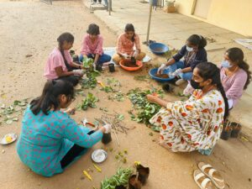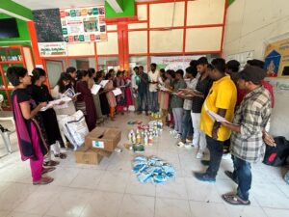

Slow Learners:
Slow learners are provided with remedial coaching in areas of difficulty. Further, the sessions are made more interactive in order to increase student interaction and thereby, facilitate understanding. Students are also encouraged to help each other and through this, understand concepts better.

Advanced Learners:
Advanced learners are encouraged to take up independent research that permits them to know and understand a topic in depth. The department also encourages students to do research on autobiography of famous Entrepreneurs. Additionally, the faculty encourage students to do Professional exams like AO and AEO.
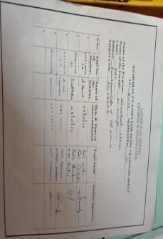
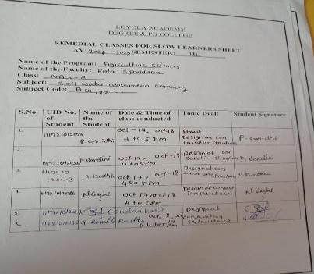
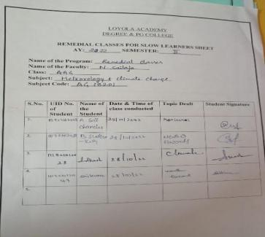
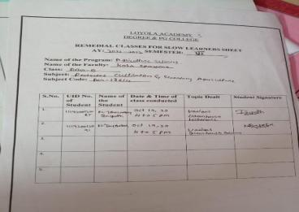
Department of CDS:

The Computer Data Science Department is an academic department that focuses on the study of data science and computer technologies. It offers degree programs, courses, and research opportunities related to data analytics, artificial intelligence, machine learning, and other related fields. Students in this department may learn about the latest techniques and technologies in data processing, analysis, and visualization, explore the ethical and legal considerations related to data management and privacy, and develop practical skills for working in the data science industry. The department may also collaborate with businesses, government agencies, and other organizations to provide real-world projects and internships for students.This dept applied an individual and peer teaching methods to give the basics to students to clear their subjects in semester subjects.

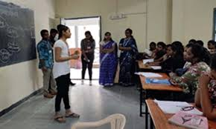

Slow Learners:
Slow learners are provided with remedial coaching in areas of difficulty. Further, the sessions are made more interactive in order to increase student interaction and thereby, facilitate understanding. Students are also encouraged to help each other and through this, understand concepts better.

Advanced Learners:
Advanced learners are encouraged to take up independent research that permits them to know and understand a topic in depth. The department also encourages students to do research on autobiography of famous Entrepreneurs. Additionally, the faculty encourage students to do Professional exams.

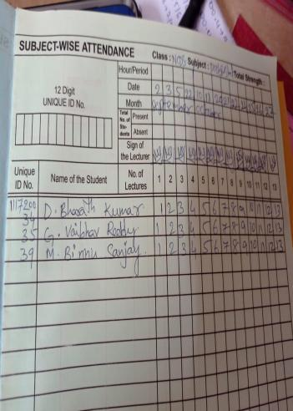
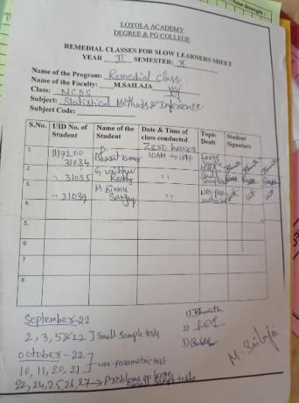

Department of CS:

Computer Science is an academic discipline that focuses on the study of computers, computation, and related technologies. It covers a wide range of topics, including computer programming, algorithms, software design and development, computer hardware, computer networking, databases, and artificial intelligence. Students in Computer Science programs may learn about the theoretical foundations of computing, develop practical programming and problem-solving skills, and gain an understanding of how computer systems are designed and used in various contexts. Graduates of Computer Science programs may pursue careers in a variety of fields, including software engineering, information technology, data analysis, computer security, and research and development.

Slow Learners:
Slow learners are provided with remedial coaching in areas of difficulty. Further, the sessions are made more interactive in order to increase student interaction and thereby, facilitate understanding. Students are also encouraged to help each other and through this, understand concepts better.

Advanced Learners:
Advanced learners are encouraged to take up independent research that permits them to know and understand a topic in depth. The department also encourages students to do research on autobiography of famous Entrepreneurs. Additionally, the faculty encourage students to do Professional exams.
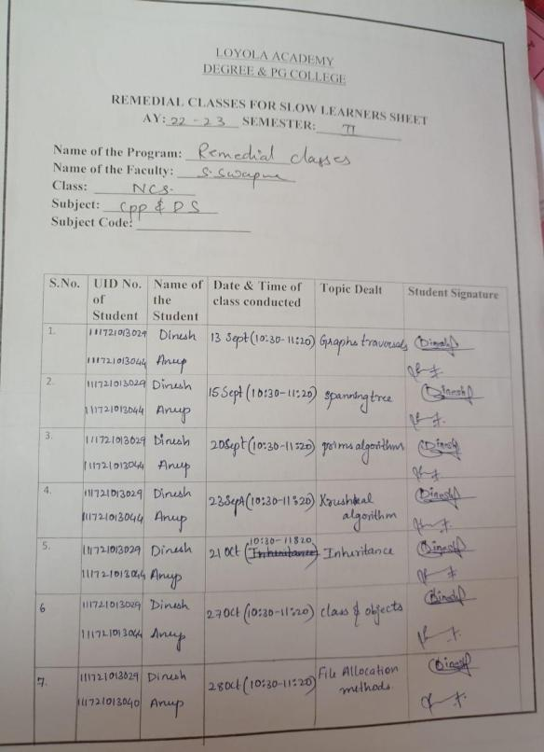
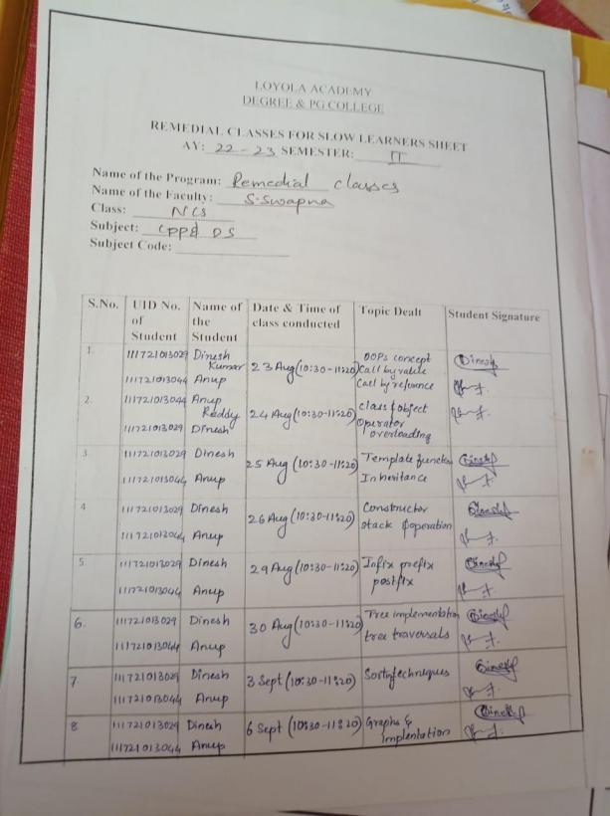

Department of Bachelors of Business Administration:

BBA programs typically cover a range of topics, including accounting, finance, marketing, operations management, organizational behavior, and entrepreneurship. Students in BBA programs may develop skills in problem-solving, critical thinking, communication, and teamwork, as well as gain an understanding of business concepts and practices. BBA graduates may pursue careers in a variety of fields, including business management, marketing, finance, human resources, and consulting. Some graduates may also go on to pursue further education in fields such as business, law, or entrepreneurship.

Slow Learners:
Slow learners are provided with remedial coaching in areas of difficulty. Further, the sessions are made more interactive in order to increase student interaction and thereby, facilitate understanding. Students are also encouraged to help each other and through this, understand concepts better.

Advanced Learners:
Advanced learners are encouraged to take up independent research that permits them to know and understand a topic in depth. The department also encourages students to do research on autobiography of famous Entrepreneurs. Additionally, the faculty encourage students to do Professional exams.
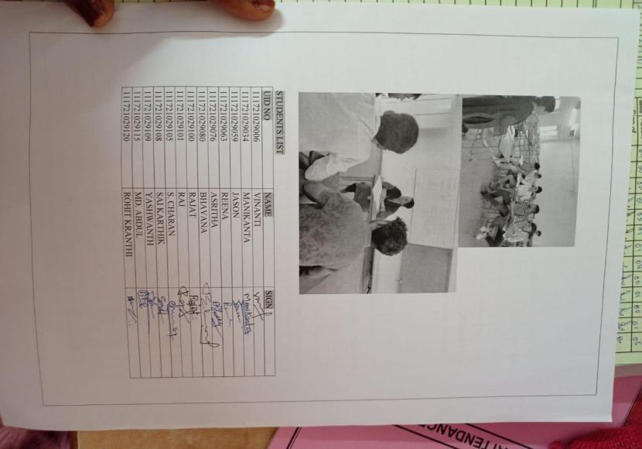
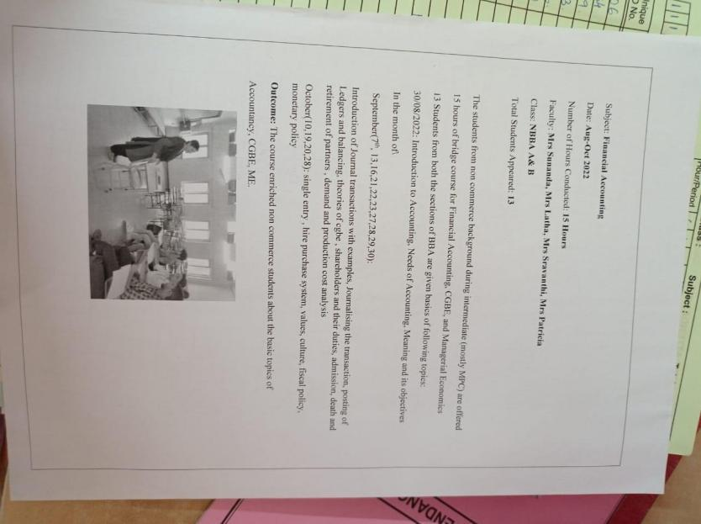

Department of Computer Science Artificial Intelligence:

Computer Science and Artificial Intelligence, which is a field of study that combines the principles of computer science with the concepts of artificial intelligence. It involves the development of algorithms and techniques for creating intelligent machines and systems that can perform tasks that normally require human intelligence. CSAI covers a wide range of topics, including machine learning, natural language processing, computer vision, robotics, and cognitive computing. Students in CSAI programs may learn about the theoretical foundations of artificial intelligence, develop programming and problem-solving skills for building intelligent systems, and gain an understanding of how artificial intelligence can be applied in various contexts.

Slow Learners:
Slow learners are provided with remedial coaching in areas of difficulty. Further, the sessions are made more interactive in order to increase student interaction and thereby, facilitate understanding. Students are also encouraged to help each other and through this, understand concepts better.

Advanced Learners:
Advanced learners are encouraged to take up independent research that permits them to know and understand a topic in depth. The department also encourages students to do research on autobiography of famous Entrepreneurs. Additionally, the faculty encourage students to do Professional exams.

REMEDIAL CLASSES FOR THE YEAR 2021-22
S.No | Name of the Department | Name of the Faculty conducted Remedial | Subject
1 | BBA | Mary Patricia | Financial Accounting
2 | BBA | Sunanda | CGBE
3 | BBA | Sravanthi | Manegerial Economics
4 | BBA | Latha | Financial Accounting
5 | NCSAI | Arpitha Rani | CPP & DS
6 | ACSAI | M. Sailaja | Probability and Statistics.
7 | NCS | S. Swapna | CPP and DS
8 | AAG | Mrs. N. Sailaja | Meteorology and Climate change
9 | AAG | Mrs. Spandana | Soil Water Conservation& engineering
10 | NCDS | M Sailaja | Statistical methods and Inference
11 | DAG-B | Mrs. Spandana | Protected cultivation and Secondary Agriculture
12 | AAG | Mrs Sailaja | Fundamentals of Soil Science

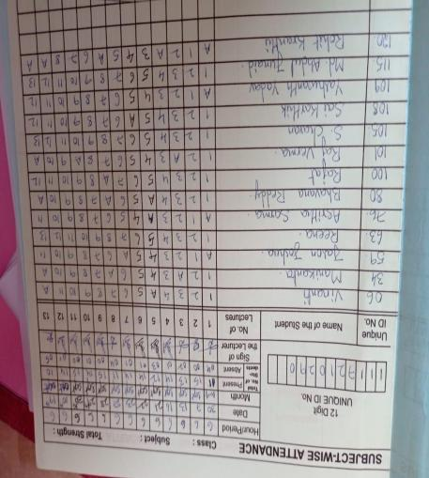
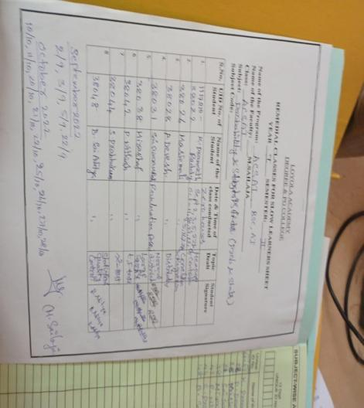
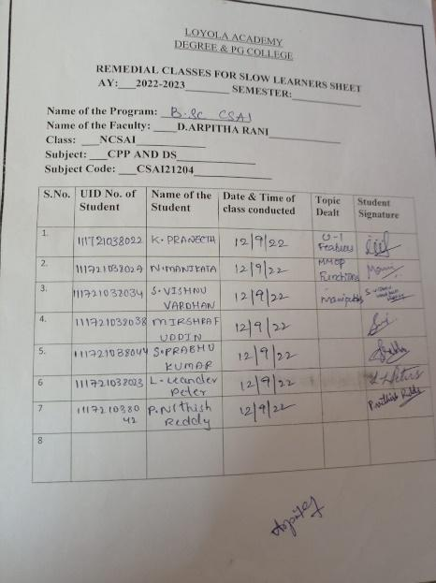
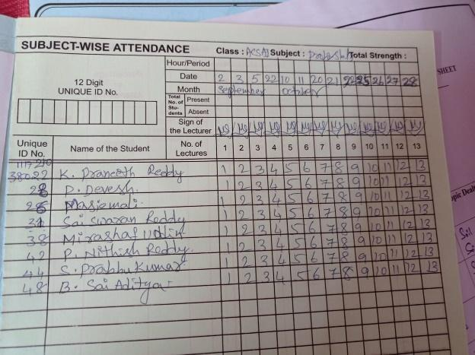

Executive Summary
Purpose:To analyze and compare remedial progress and challenges in UG classes from 2021to 2022.
Key Finding: Overall, there has been a 15% improvement in pass rates and a reduction in failure rates in core subjects like Mathematics-I,Mathematics-II ,Informatics,sciences & commerce..

By implementing remedial classes pass percentage has been increased from all the departments.

Overall Performance Comparison
Metric | Previous Year ([2020-2021]) | Current Year ([2021-2022]) | Difference (+/-) | % Change
Total Students in Remediation | 120 | 105 | -15 | -12.5%
Average Pass Rate (%) | 68% | 73% | +5% | +7.35%
Subjects Requiring Remediation | Maths,Computers,Sciences,commerce | Maths,Computers,Sciences,commerce | Maths,Commerce

Challenges Identified:
- · Persistent difficulty in [specific subjects like Mathematics,Coding
subjects,Management subjects].
- · Attendance issues during remedial sessions.

Recommendations
Enhanced Remedial Scheduling: Increase the frequency and flexibility of remedial classes.
Student Monitoring: Implement early warning systems to identify struggling students sooner.
Use of Technology: Incorporate online remedial modules for self-paced learning.
Parental Involvement: Strengthen communication with parents about their wards progress.
Conclusion:
While there has been progress in certain areas,Loyola college is providing continued effort to ensure that every student receives the support they need to succeed. Focused remedial measures, coupled with proactive monitoring, will be key in improving outcomes in the coming years.

